

Таблица истинности.

|  |  |  |  |  |  |  |  |
| --- | --- | --- | --- | --- | --- | --- | --- |
| **№** | **x1** | **x2** | **x3** | **x4** | **x5** | **x6** | **c0c1c2c3** |
| 1 | 0 | 0 | 0 | 0 | 0 | 0 | 0000 |
| 2 | 0 | 0 | 0 | 0 | 0 | 1 | 0001 |
| 3 | 0 | 0 | 0 | 0 | 1 | 0 | 0000 |
| 4 | 0 | 0 | 0 | 0 | 1 | 1 | 0001 |
| 5 | 0 | 0 | 0 | 1 | 0 | 0 | 0000 |
| 6 | 0 | 0 | 0 | 1 | 0 | 1 | 0001 |
| 7 | 0 | 0 | 0 | 1 | 1 | 0 | 0000 |
| 8 | 0 | 0 | 0 | 1 | 1 | 1 | 0001 |
| 9 | 0 | 0 | 1 | 0 | 0 | 0 | 0000 |
| 10 | 0 | 0 | 1 | 0 | 0 | 1 | 0001 |
| 11 | 0 | 0 | 1 | 0 | 1 | 0 | 0000 |
| 12 | 0 | 0 | 1 | 0 | 1 | 1 | 0001 |
| 13 | 0 | 0 | 1 | 1 | 0 | 0 | 0000 |
| 14 | 0 | 0 | 1 | 1 | 0 | 1 | 0001 |
| 15 | 0 | 0 | 1 | 1 | 1 | 0 | 0000 |
| 16 | 0 | 0 | 1 | 1 | 1 | 1 | 0001 |
| 17 | 0 | 1 | 0 | 0 | 0 | 0 | 0000 |
| 18 | 0 | 1 | 0 | 0 | 0 | 1 | 0001 |
| 19 | 0 | 1 | 0 | 0 | 1 | 0 | 0000 |
| 20 | 0 | 1 | 0 | 0 | 1 | 1 | 0001 |
| 21 | 0 | 1 | 0 | 1 | 0 | 0 | 0000 |
| 22 | 0 | 1 | 0 | 1 | 0 | 1 | 0001 |
| 23 | 0 | 1 | 0 | 1 | 1 | 0 | 0000 |
| 24 | 0 | 1 | 0 | 1 | 1 | 1 | 0001 |
| 25 | 0 | 1 | 1 | 0 | 0 | 0 | 0000 |
| 26 | 0 | 1 | 1 | 0 | 0 | 1 | 0001 |
| 27 | 0 | 1 | 1 | 0 | 1 | 0 | 0000 |
| 28 | 0 | 1 | 1 | 0 | 1 | 1 | 0001 |
| 29 | 0 | 1 | 1 | 1 | 0 | 0 | 0000 |
| 30 | 0 | 1 | 1 | 1 | 0 | 1 | 0001 |
| 31 | 0 | 1 | 1 | 1 | 1 | 0 | 0000 |
| 32 | 0 | 1 | 1 | 1 | 1 | 1 | 0001 |
| 33 | 1 | 0 | 0 | 0 | 0 | 0 | 0000 |
| 34 | 1 | 0 | 0 | 0 | 0 | 1 | 0001 |
| 35 | 1 | 0 | 0 | 0 | 1 | 0 | 0000 |
| 36 | 1 | 0 | 0 | 0 | 1 | 1 | 0001 |
| 37 | 1 | 0 | 0 | 1 | 0 | 0 | 0000 |
| 38 | 1 | 0 | 0 | 1 | 0 | 1 | 0001 |
| 39 | 1 | 0 | 0 | 1 | 1 | 0 | 0000 |
| 40 | 1 | 0 | 0 | 1 | 1 | 1 | 0001 |
| 41 | 1 | 0 | 1 | 0 | 0 | 0 | 0000 |
| 42 | 1 | 0 | 1 | 0 | 0 | 1 | 0001 |
| 43 | 1 | 0 | 1 | 0 | 1 | 0 | 0000 |
| 44 | 1 | 0 | 1 | 0 | 1 | 1 | 0001 |
| 45 | 1 | 0 | 1 | 1 | 0 | 0 | 0000 |
| 46 | 1 | 0 | 1 | 1 | 0 | 1 | 0001 |
| 47 | 1 | 0 | 1 | 1 | 1 | 0 | 0000 |
| 48 | 1 | 0 | 1 | 1 | 1 | 1 | 0001 |
| 49 | 1 | 1 | 0 | 0 | 0 | 0 | 0000 |
| 50 | 1 | 1 | 0 | 0 | 0 | 1 | 0001 |
| 51 | 1 | 1 | 0 | 0 | 1 | 0 | 0000 |
| 52 | 1 | 1 | 0 | 0 | 1 | 1 | 0001 |
| 53 | 1 | 1 | 0 | 1 | 0 | 0 | 0000 |
| 54 | 1 | 1 | 0 | 1 | 0 | 1 | 0001 |
| 55 | 1 | 1 | 0 | 1 | 1 | 0 | 0000 |
| 56 | 1 | 1 | 0 | 1 | 1 | 1 | 0001 |
| 57 | 1 | 1 | 1 | 0 | 0 | 0 | 0000 |
| 58 | 1 | 1 | 1 | 0 | 0 | 1 | 0001 |
| 59 | 1 | 1 | 1 | 0 | 1 | 0 | 0000 |
| 60 | 1 | 1 | 1 | 0 | 1 | 1 | 0001 |
| 61 | 1 | 1 | 1 | 1 | 0 | 0 | 0000 |
| 62 | 1 | 1 | 1 | 1 | 0 | 1 | 0001 |
| 63 | 1 | 1 | 1 | 1 | 1 | 0 | 0000 |
| 64 | 1 | 1 | 1 | 1 | 1 | 1 | 0001 |

Минимизация на картах Карно.

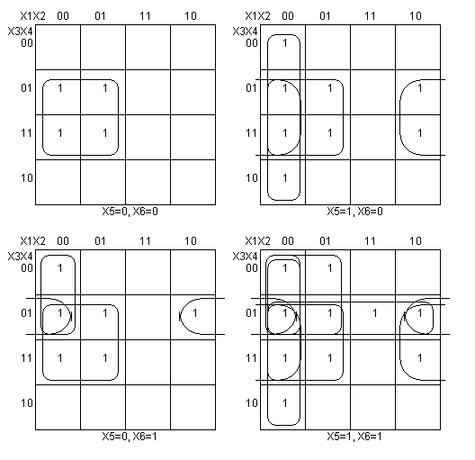

|  |  |  |
| --- | --- | --- |
| **c0** | Sa | Sb |
| 00XX1X | 12 | 19 |
| 000XX1 |
| 0X0X11 |
| X001X1 |
| 0XX1XX |
| XX0111 |
| X0X11X |

С0=X̅1X̅2X5 + X̅1X̅2X̅3X6 + X̅1X̅3X5X6 + X̅2X̅3X4X6 + X̅1X4 + X̅3X4X5X6 + X̅2X4X5

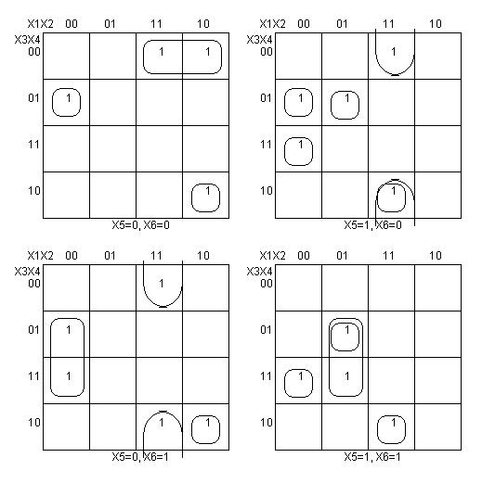

|  |  |  |
| --- | --- | --- |
| **c1** | Sa | Sb |
| 11101X | 41 | 51 |
| 11X001 |
| 00111X |
| 01011X |
| 01X111 |
| 0001X0 |
| 1X0000 |
| 10100X |
| 00X101 |
| 11X010 |

C1=X1X2X3X̅4X5 + X1X2X̅4X̅5X6 + X̅1X̅2X3X4X5 + X̅1X2X̅3X4X5 + X̅1X2X4X5X6 + X̅1X̅2X̅3X4X̅6 + X1X̅3X̅4X̅5X̅6 + X1X̅2X3X̅4X̅5 + X̅1X̅2X4X̅5X6 + X1X2X̅4X5X̅6

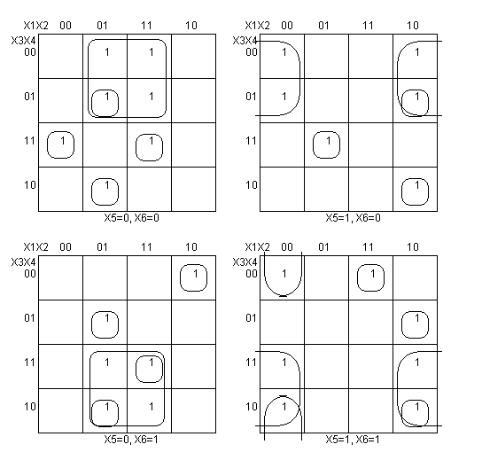

|  |  |  |
| --- | --- | --- |
| **c2** | Sa | Sb |
| 001100 | 59 | 73 |
| 011110 |
| 100001 |
| 110011 |
| X00X10 |
| X01X11 |
| X10X00 |
| X11X01 |
| 00X011 |
| 01010X |
| 01100X |
| 10011X |
| 10101X |
| 11110X |

C2=X̅1X̅2X3X4X̅5X̅6 + X̅1X2X3X4X5X̅6 + X1X̅2X̅3X̅4X̅5X6 + X1X2X̅3X̅4X5X6 + X̅2X̅3X5X̅6 + X̅2X3X5X6 + X2X̅3X̅5X̅6 + X2X3X̅5X6 + X̅1X̅2X̅4X5X6 + X̅1X2X̅3X4X̅5 + X̅1X2X3X̅4X̅5 + X1X̅2X̅3X4X5 + X1X̅2X3X̅4X5 + X1X2X3X4X̅5

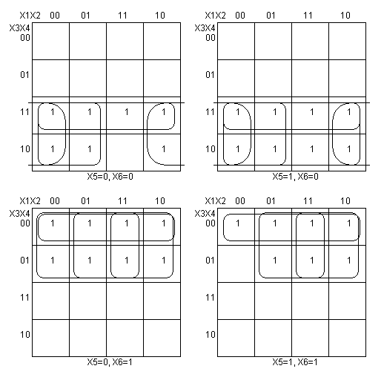

|  |  |  |
| --- | --- | --- |
| **c3** | Sa | Sb |
| 0X1XX0 | 18 | 26 |
| 1X0XX1 |
| X01XX0 |
| X10XX1 |
| XX00X1 |
| XX0X01 |
| XX11X0 |
| XX1X10 |

C3=X̅1X3X̅6 + X1X̅3X6 + X̅2X3X̅6 + X2X̅3X6 + X̅3X̅4X6 + X̅3X̅5X6 + X3X4X̅6 + X3X5X̅6

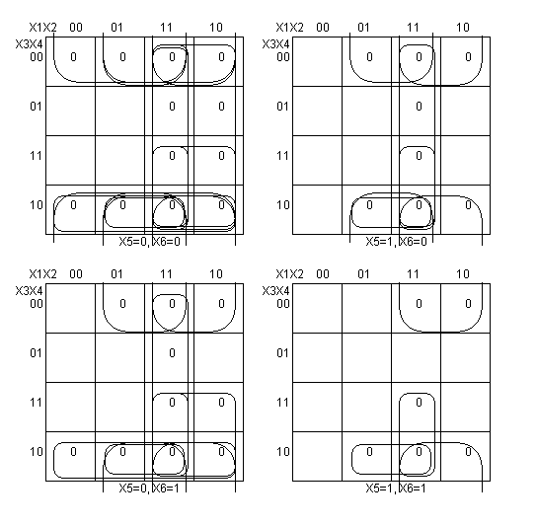

|  |  |  |
| --- | --- | --- |
| **c0** | Sa | Sb |
| 11XX0X | 27 | 37 |
| 1XX0XX |
| 11XXX0 |
| XXX000 |
| 1XXX00 |
| 1X1X0X |
| X110XX |
| X1X0X0 |
| X1X00X |
| XX100X |

С0=(X̅1 v X̅2 v X̅3)(X̅1 v X̅2 v X5)(X̅1 v X4)(X̅1 v X̅2 v X6)(X4 v X5 v X6)(X̅1 v X5 v X6)(X̅1 v X̅3 v X5)(X̅2 v X̅3 v X4)(X̅2 v X4 v X6)(X̅2 v X4 v X5)(X̅3 v X4 v X5)

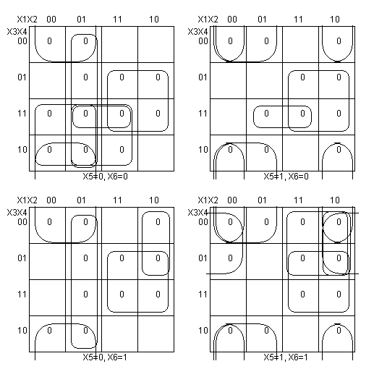

|  |  |  |
| --- | --- | --- |
| **c1** | Sa | Sb |
| 0XX0XX | 27 | 37 |
| 1XX1XX |
| X00X11 |
| X11X00 |
| 01XX0X |
| 0X1X00 |
| 100XX1 |
| 1X0X11 |
| X0X01X |
| X111X0 |

C1=(X1 v X4)(X̅1 v X̅4)(X2 v X3 v X̅5 v X̅6)(X̅2 v X̅3 v X5 v X6)(X1 v X̅2 v X5)(X1 v X̅3 v X5 v X6)(X̅1 v X2 v X3 v X̅6)(X̅1 v X3 v X̅5 v X̅6)(X2 v X4 v X̅5)(X̅2 v X̅3 v X̅4 v X6)

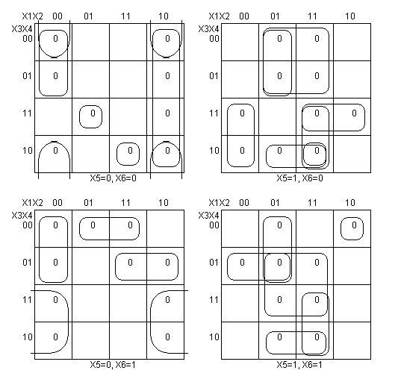

|  |  |  |
| --- | --- | --- |
| **c2** | Sa | Sb |
| 011100 | 65 | 82 |
| 100011 |
| X10X10 |
| X0X000 |
| 000X0X |
| 10XX00 |
| X01X01 |
| X1X111 |
| X1101X |
| 111X1X |
| 010X1X |
| 001X10 |
| X10001 |
| 1X0101 |
| 1X1110 |
| 0X0111 |
| 1110X0 |

C2=(X1 v X̅2 v X̅3 v X̅4 v X5 v X6)(X̅1 v X2 v X3 v X4 v X̅5 v X̅6)(X̅2 v X3 v X̅5 v X6)(X2 v X4 v X5 v X6)(X1 v X2 v X3 v X5)(X̅1 v X2 v X5 v X6)(X2 v X̅3 v X5 v X̅6)(X̅2 v X̅4 v X̅5 v X̅6)(X̅2 v X̅3 v X4 v X̅5)(X̅1 v X̅2 v X̅3 v X̅5)(X1 v X̅2 v X3 v X̅5)(X1 v X2 v X̅3 v X̅5 v X6)(X̅2 v X3 v X4 v X5 v X̅6)(X̅1 v X3 v X̅4 v X5 v X̅6)(X̅1 v X̅3 v X̅4 v X̅5 v X6)(X1 v X3 v X̅4 v X̅5 v X̅6)(X̅1 v X̅2 v X̅3 v X4 v X6)

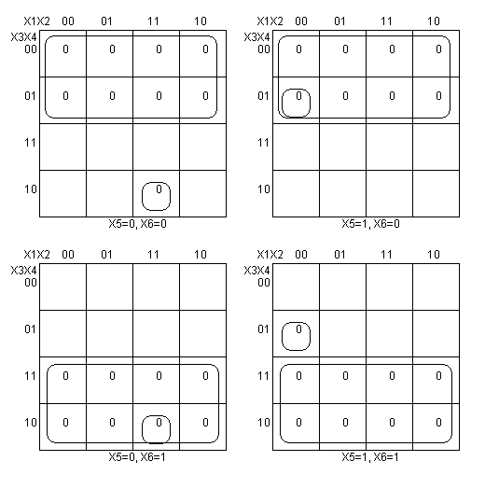

|  |  |  |
| --- | --- | --- |
| **c3** | Sa | Sb |
| XX0XX0 | 10 | 14 |
| XX1XX1 |
| 00011X |
| 11100X |

C3=(X3 v X6)(X̅3 v X̅6)(X1 v X2 v X3 v X̅4 v X̅5)(X̅1 v X̅2 v X̅3 v X4 v X5);

Общая стоимость минимального покрытия :

199 по единицам

204 по нулям

Факторизация и декомпозиция:

z = X̅1 X̅2 X5

C0 = X̅2 X̅3 X6 X4 + X̅1 X̅2 X̅3 X6 + X1 X5 X̅3 X6 X4 + X̅1 X2 X5 X̅3 X6 + X̅2 X5 X4 + z + X̅1 X4

C1 = X1 X2 X̅5 X̅3 X̅4 + X1 X2 X5 X̅6 X̅4 + X1 X̅2 X̅5 X̅6 X̅4 + X1 X2 X3 X6 X̅4 + X1 X̅5 X3 X6 X̅4 + X̅1 X5 X̅3 X̅6 X4 + X̅1 X̅2 X̅5 X̅3 X4 + X̅1 X2 X5 X6 X4 + z X3 X4 + X̅1 X̅2 X̅5 X6 X4

C2 = X1 X̅2 X5 X̅6 X̅4 + X1 X2 X5 X̅3 X6 X̅4 + X̅1 X2 X5 X3 X̅6 X4 + X1 X̅2 X̅5 X̅3 X6 X̅4 + X̅1 X̅2 X̅5 X3 X̅6 X4 + X1 X2 X̅5 X3 X̅6 X4 + X̅1 X2 X̅5 X3 X̅4 + X̅1 X2 X̅5 X6 X4 + X1 X̅2 X5 X6 X4 + z X6 X̅4 + X2 X̅5 X̅3 X̅6 + X2 X̅5 X3 X6 + X̅2 X5 X̅3 X̅6 + X̅2 X5 X3 X6

C3 = X1 X2 X̅5 X3 X̅6 X4 + X1 X5 X̅3 X6 X4 + X̅1 X2 X5 X̅3 X6 + X̅1 X3 X̅6 + X5 X3 X̅6 + X̅2 X3 X̅6 + X̅3 X6 X̅4 + X̅5 X̅3 X6

Sq = 189